linear spatial filter
code:
import cv2
import numpy as np
import matplotlib.pyplot as plt
dog_image = cv2.imread("dog.jpg")
if dog_image is None:
raise FileNotFoundError("The file 'dog.png' was not found. Make sure it's in the same directory as the script.")
dog_image_rgb = cv2.cvtColor(dog_image, cv2.COLOR_BGR2RGB)
kernel_size = (5, 5) # Size of the kernel (larger values = more blur)
blurred_image = cv2.GaussianBlur(dog_image_rgb, kernel_size, sigmaX=0)
plt.figure(figsize=(12, 6))
plt.subplot(1, 2, 1)
plt.title("Original Image")
plt.imshow(dog_image_rgb)
plt.axis("off")
plt.subplot(1, 2, 2)
plt.title("Gaussian Blurred Image")
plt.imshow(blurred_image)
plt.axis("off")
plt.tight_layout()
plt.show()

Explanation of the Code:
- Image Loading:
  - The image dog.png is loaded using cv2.imread.
  - If the image doesn't exist, an error is raised.
- Color Conversion:
  - OpenCV loads images in BGR format, so the image is converted to RGB for proper visualization using matplotlib.
- Gaussian Blur:
  - A Gaussian Blur filter is applied using cv2.GaussianBlur with a kernel size of 5x5. This is a linear spatial filter that smoothens the image and reduces noise.
- Visualization:
  - The original and blurred images are displayed side-by-side using matplotlib.

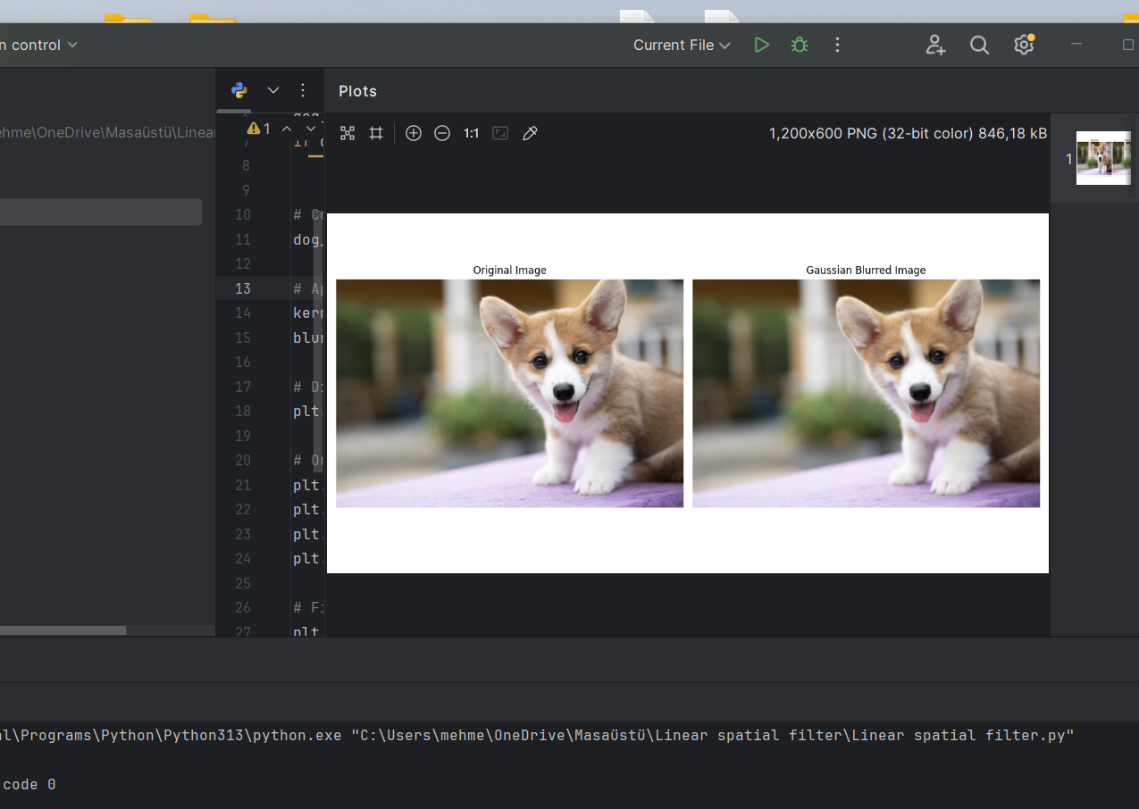
Output:

Report:
The Gaussian Blur filter effectively reduces high-frequency noise in the image, leading to a smooth appearance. This linear filter works by convolving the image with a Gaussian kernel, ensuring the edges remain somewhat preserved compared to other filters like mean blur. For larger kernel sizes, the image appears more blurred.

